**Salesforce Project Implementation Phases**

**Phase 7: Integration & External Access**

This phase focuses on connecting Salesforce with external systems and managing data exchange securely. The following components are implemented:

* **Named Credentials**

A secure way to store authentication settings (endpoint URL, username, password, OAuth tokens).

**Use Case:** Instead of hardcoding API credentials in Apex, use Named Credentials.

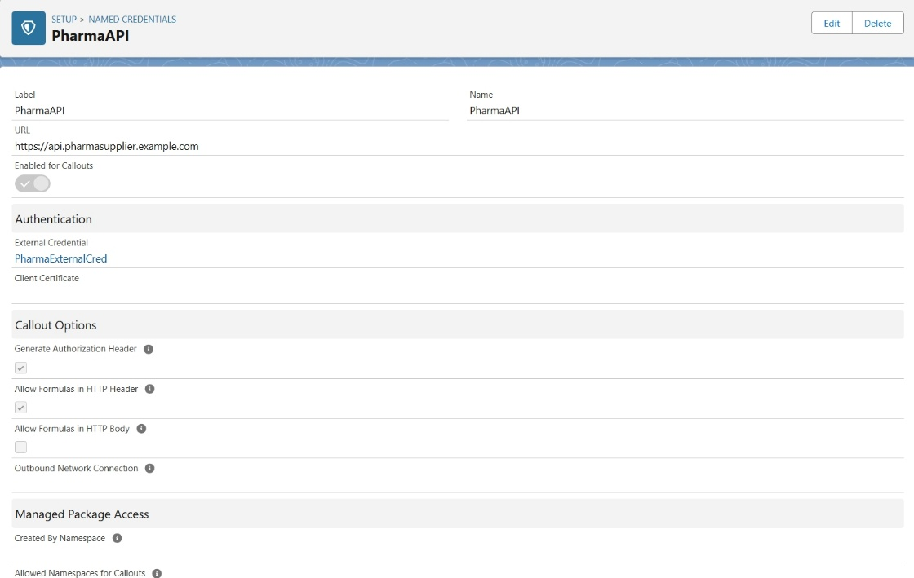

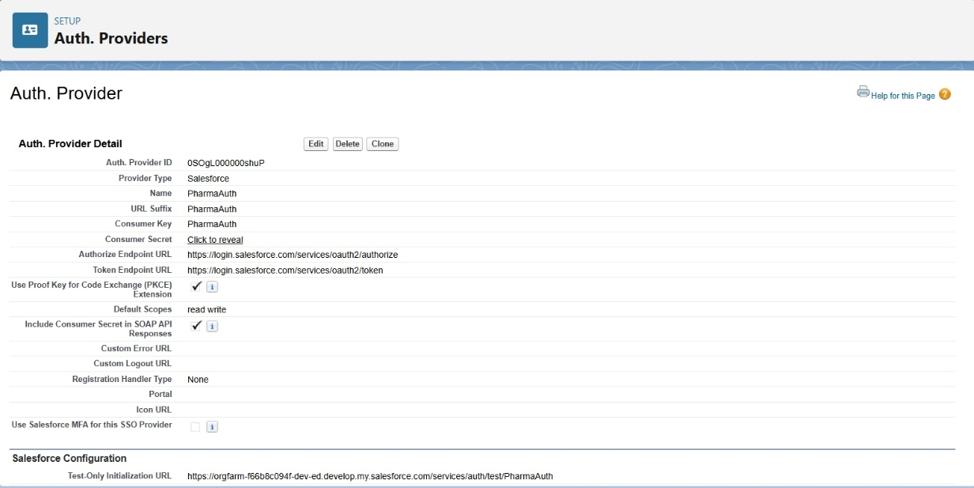

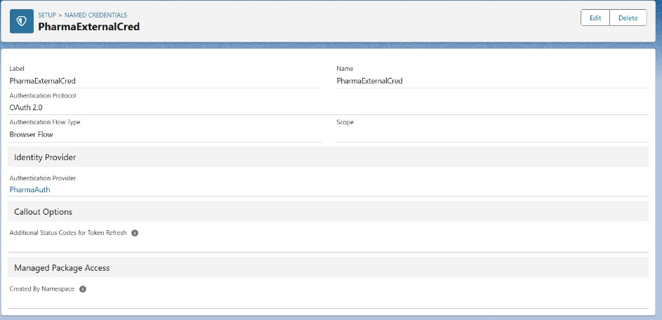

* **External Services**

Declarative way to call REST APIs without writing Apex, using an OpenAPI (Swagger) schema.

**Use Case:** Connect to hospital’s Appointment API or demo Pet Store API.

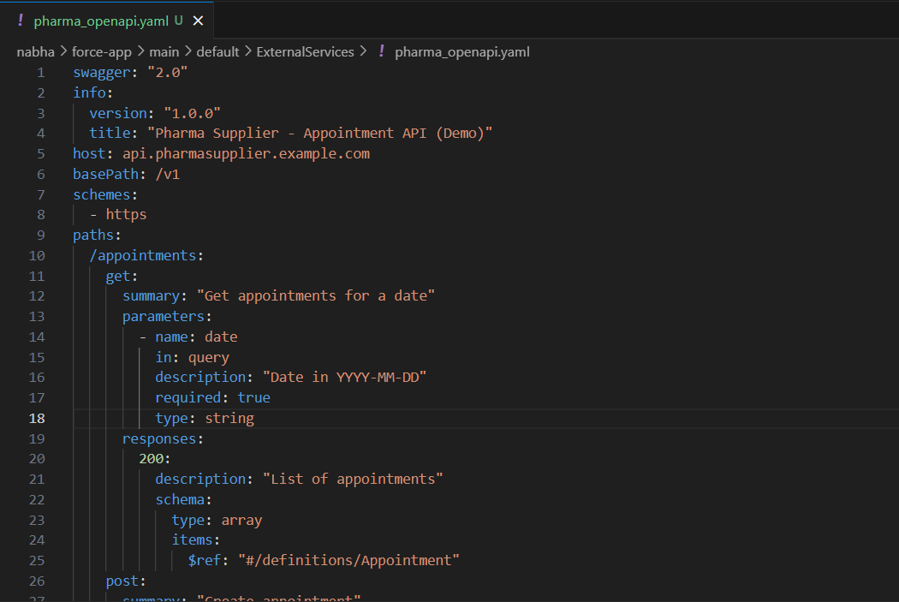

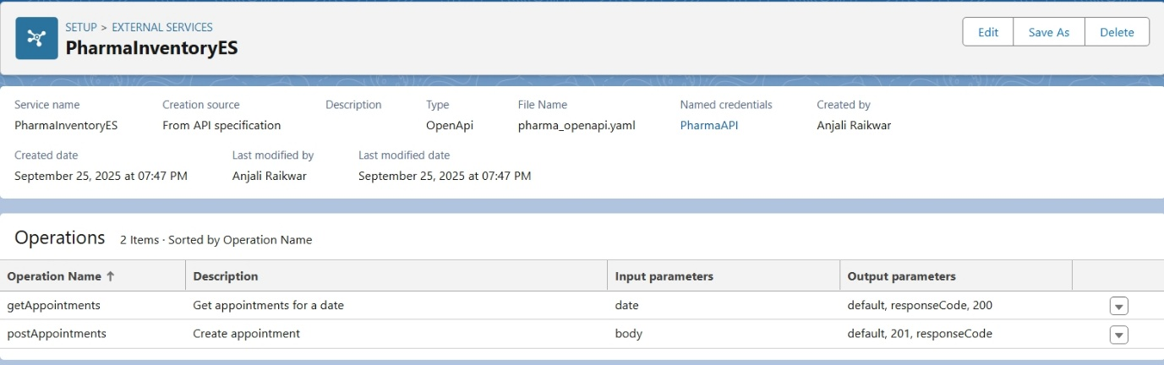

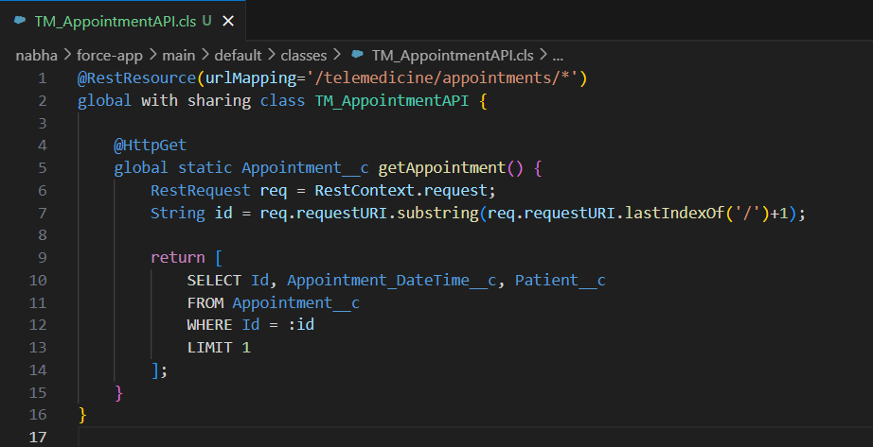

* **Web Services (REST/SOAP)**

Salesforce can expose its logic/data as web services or consume external ones.

**Exposing:**

REST → Use @RestResource annotation in Apex.

SOAP → Use global class with webService keyword.



* **Callouts**

Outbound HTTP requests from Salesforce to external services.

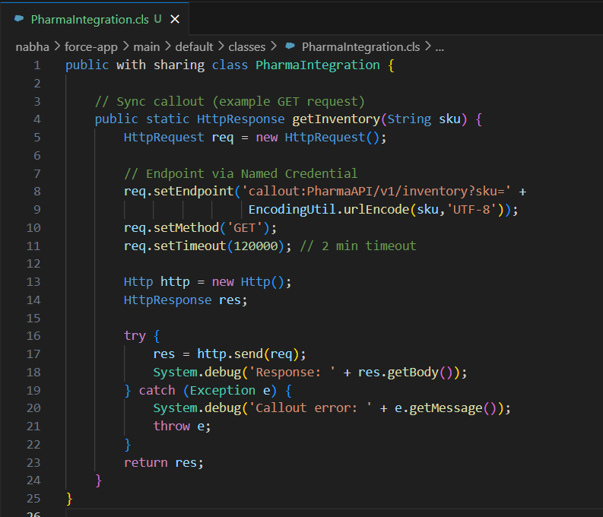

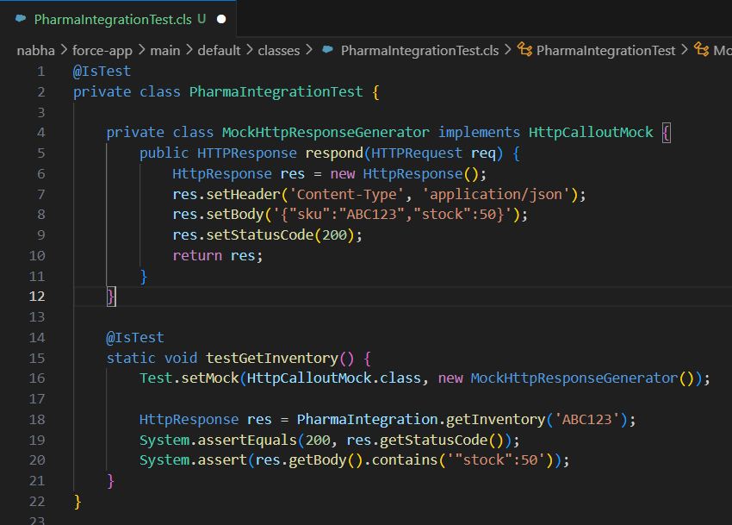

* **Platform Events**

Event-driven architecture in Salesforce (publish-subscribe model).

**Use Case:** Notify external systems when an appointment is booked or cancelled.

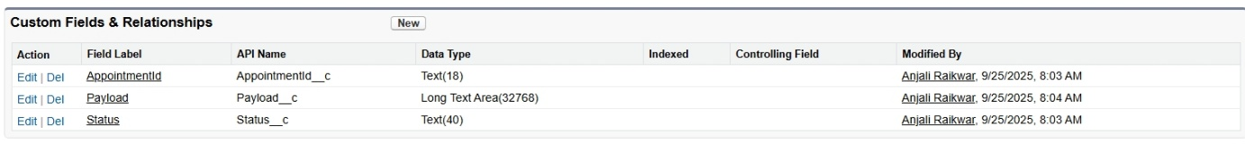

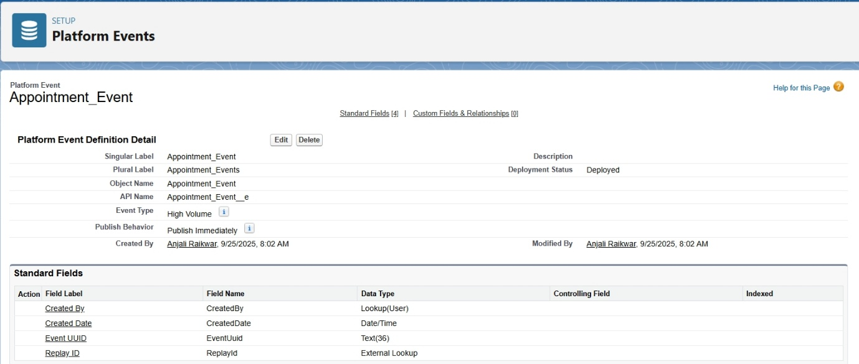

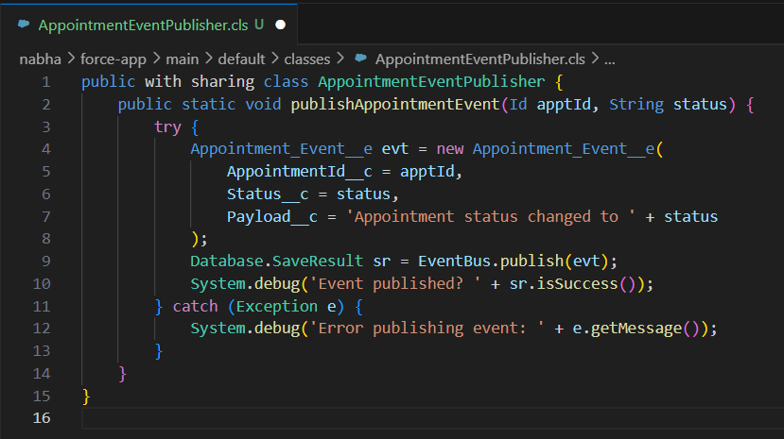

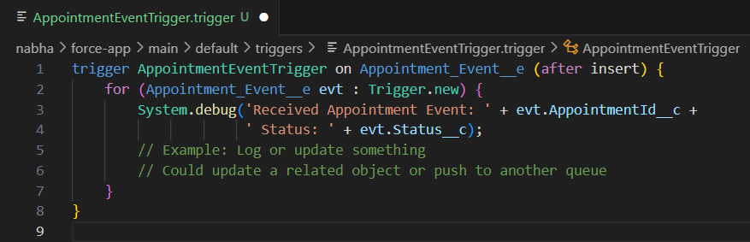

* **Change Data Capture**

Automatically streams changes (Create, Update, Delete, Undelete) of Salesforce records.

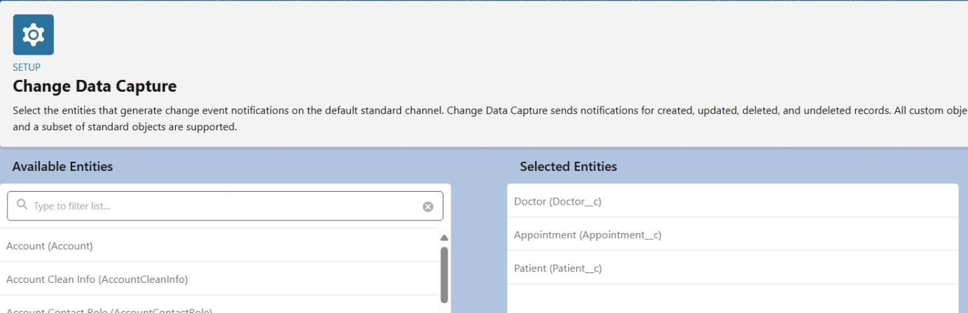

* **Salesforce Connect**

Lets Salesforce access external data in real time without storing it.

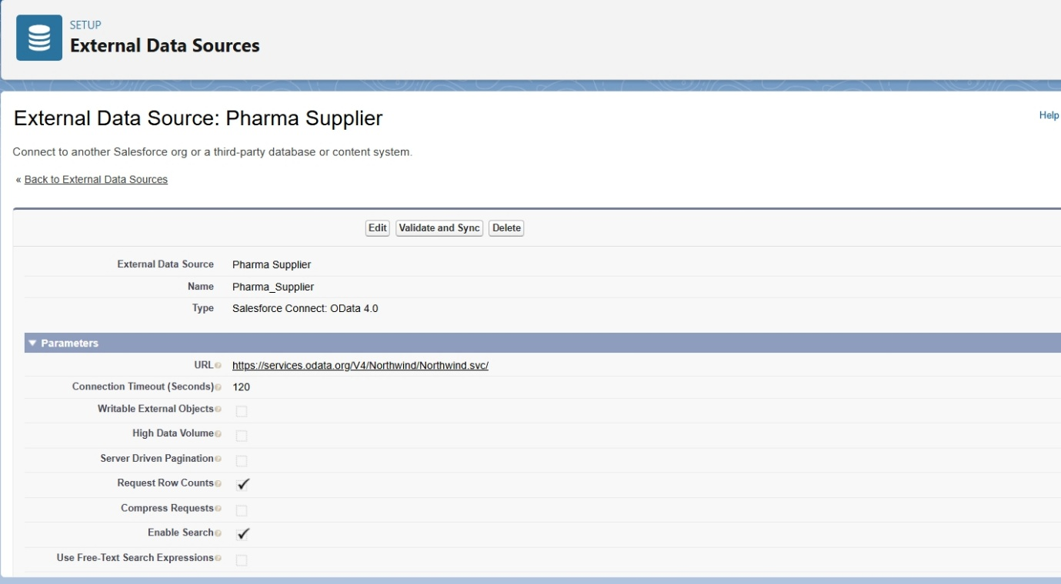

* **API Limits**

Salesforce enforces API limits per 24 hours (depends on edition & licenses).

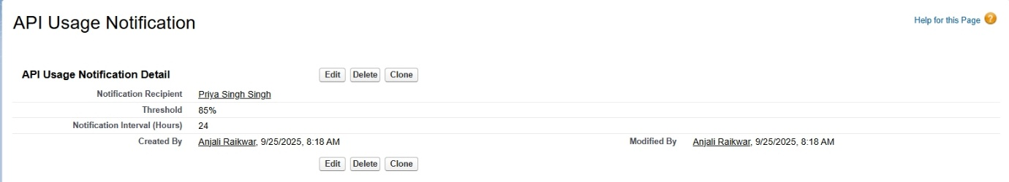

* **OAuth & Authentication**

Secure authentication mechanism for APIs.

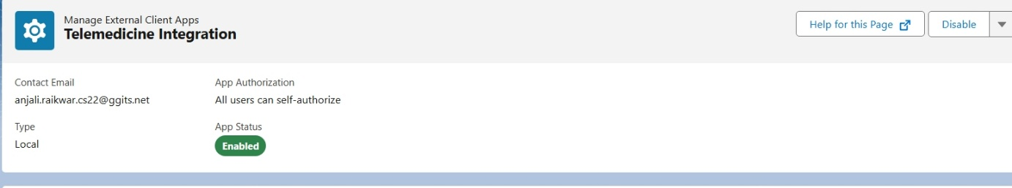

* **Remote Site Settings**

Whitelist external domains before Salesforce can make callouts.

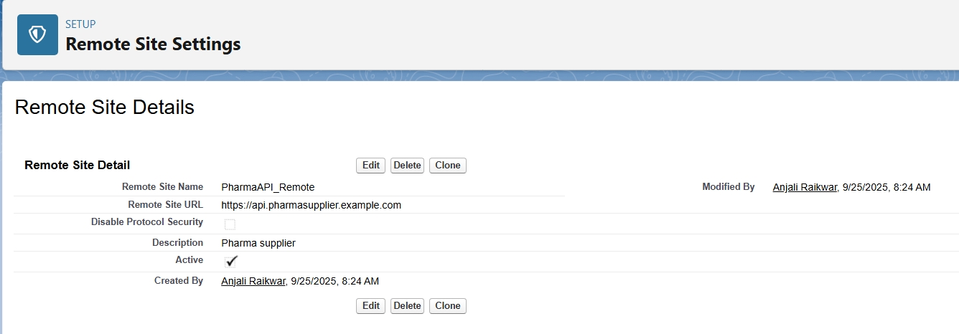

**Deliverables in Phase 7**

* Named Credentials → Store endpoint + auth.
* External Services → Declarative API calls.
* Web Services → Expose/consume SOAP & REST.
* Callouts → Programmatic API calls.
* Platform Events & CDC → Event-driven data sync.
* Salesforce Connect → Real-time external data access.
* API Limits → Monitor & optimize API usage.
* OAuth & Auth → Secure integrations.
* Remote Site Settings → Whitelist domains.